8.85: a) If the crate had final speed , J&J have speed 4.00 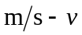 relative to the ice, and so Solving for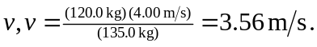 b) After Jack jumps, the speed of the crate is 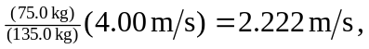 and the momentum of Jill and the crate is 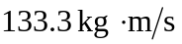. After Jill jumps, the crate has a speed and Jill has speed 4.00 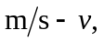 and so 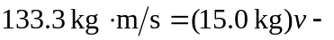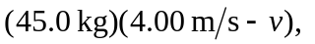and solving for gives 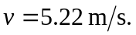 c) Repeating the calculation for part (b) with Jill jumping first gives a final speed of 